Technical Information IZAWA PIGMENT CO., LTD.

revised: 6/10/2023

SELECTION 78M lead-and cadmium-free inglaze metallic colors

1. General Information

Selection 78M series is lead-and cadmium-free, intermixable, intensive inglaze metallic colors for porcelain, bone china, earthen ware, vitreous china and tile.

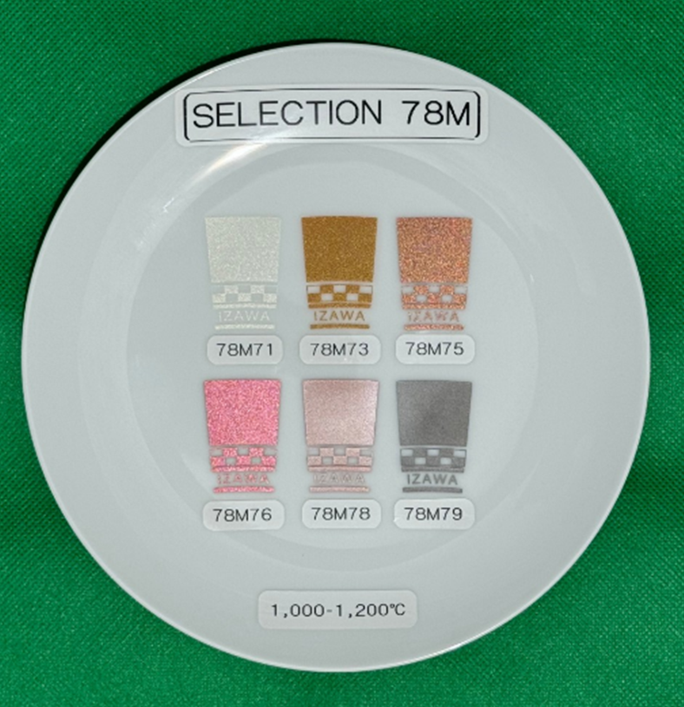

2. Firing Conditions

Type of ware | Metallic colors
Porcelain | 1100 - 1200℃
Bone China | 1000 - 1150℃
Earthen ware | 1100 - 1180℃
Vitreous China | 1100 - 1180℃
Tile | 1000 - 1180℃

Selection 78M metallic colors are suitable for fast firing of 60-120 minutes, cold-to-cold conditions. 78M71 silver and 78M73 gold show better results bellow 1180℃. 78M78 copper and 78M79 black are suitable for porcelain glaze and show smooth surface effect.

Item | Color | Comments
78M71 | White Silver | Mat and rough surface. Can mix with Selection 78 colors
78M73 | Gold | Mat and rough surface
78M75 | Copper | Mat and rough surface. Can stand higher temperature up to 1200℃
78M76 | Red | Mat and rough surface. Can stand higher temperature up to 1200℃
78M78 | Red | Glossy and smooth appearance, not suitable for soft glaze
78M79 | Black | Glossy and smooth appearance, not suitable for soft glaze

3. Application

Selection 78M metallic colors are suitable for screen-transfer printing, direct printing, spraying, pad printing and hand painting.

4. Particle size and Mesh size

Selection 78M metallic colors are recommended to print 100-200 mesh/inch (40-80 thread/cm)
Two time printing, as thinker layer, show better and stable results against higher firing temperature and longer firing cycle.
78103 underlay flux is recommended to print by 300 mesh/inch (120 thread/cm)

5. Medium ratio

Selection 78M Color: Medium PM2 | 10: 14-16
78103 underlay flux: Medium PM2 | 10: 8-10

6. Mixability

Selection 78M metallic colors can be mixed with each other in any proportions. Mixing with other Selection 78 colors can be developed a wide range of metallic effect colors. Please note following recommendations.

Underlay flux: If 78103 underlay flux is printed before printing 78M colors, it helps to remaining metallic effect. Overprinting 78103 flux is not much effective than printing as underlay flux.

Mixing white silver: To obtain colored metallic, it is suitable to mix 78M71 silver with approximate 10-20% of Selection 78 colors.

Mixing flux: 78101 flux is recommended to mix with 78M metallic colors to lighten the colors.

7. Chemical durability

Chemical durability of Selection 78M metallic colors depend on type of ware, glaze, kiln, color deposit and firing conditions. Following results were tested by porcelain, fired at 1180 ℃, with 10 minutes of soaking time and 120 minutes of cold-to-cold firing conditions of gas kiln in production.

7.1 Residual lead and cadmium content

Selection 78M metallic colors contain less than 90 ppm residual lead and less than 40 ppm residual cadmium and are therefore in compliance with Californian Proposition 65, FDA, EU and Japanese requirements.

7.2 Lead and cadmium release

According to DI EN 1388-1-2 test, Selection 78M metallic colors show lead and cadmium releases are below AAS limits.

7.3 Acid resistance

According to DI EN 1388-1-2 test, Selection 78M metallic colors do not show visible attack after immersion in a 4% acetic acid solution for 24 hours at room temperature 22±2℃.

7.4 Alkali resistance

According to ASTM C556-88 test, Selection 78M metallic colors do not show visible attack up to 4 hours.

8. Safety Data Sheet (SDS)

Safety data sheet of all of Selection 78M metallic colors are available.

The above information and statements are unsolicited. IZAWA PIGMENT CO., LTD. provides them to promote its products. The above information and statements are also believed to be accurate at the time of publication under their laboratory conditions. Use of them is at the sole discretion of the user and IZAWA PIGMENT CO., LTD. does not give any warranty with respect to any test results. In no event shall IZAWA PIGMENT CO., LTD. be liable for any direct, indirect, special, incidental, or consequential damages arising out of the use of the above information.

